**Reviewing Spotify’s Business Model & Financial Fundamentals**

**Mini-Assignment – May 14, 2020**

**Disclaimer:**

The exercise is for demonstration of financial analysis techniques only and is not intended to be a reflection on the quality or competency level of Spotify’s management team and its Board of Directors.

**Overview**

In March 2016, Spotify, a privately-held company, filed an initial annual report with regulators in Luxembourg, where the company is registered. The world’s leading music streaming service (estimated 44% market share) reported that its revenues had risen to just under €2.0 billion, an 80% increase over the prior year. Although management indicated that 2015, in many ways, was its best year ever, the company continued to lose money, reporting an operating loss of €173 million. Fast-forward to year-end 2018, and although improved, the financial situation continues to challenge Spotify’s management team. Revenue does continue to grow at double-digit levels, but the current revenue model is centred around what is considered to be largely a low-margin business (music streaming). In addition, the growth in this market sector is showing signs of slowing and is anticipated to peak in the mid-term. Profitability (Y/Y) continues to allude the company, although free cash flow has improved and the underlying liquidity position of the company remains strong. 2019 Q3 results do show improved financial performance, with subscriber growth remaining at the double-digit level and operating margin finally pushing Spotify’s financial performance into positive territory.

Considered the market leader in the music-streaming industry, Spotify, as with many emerging market opportunities, exhibits the typical “is the glass half-full or half-empty” analysis. On the one hand, its continued rapid growth in its user base (over 30%+ YOY), to just an estimated 250 million subscribers, offers investors reasons to believe that its market position justifies its current valuation and competitive strength, relative to rivals such as Apple, Amazon, iHeartRadio, Rdio, Pandora, Soundcloud, Deezer, Joox, QQ Music, or KKBOX to name a few. Having said that, the inability to generate strong financial results casts longer-term concerns relating to the underlying business model and the level of scale required to become profitable if, given the way the industry works, such a position is obtainable. There are few examples to date, of mass-market appeal subscription-only, freeium-based models which have demonstrated a proven path to profitability.

Recognizing some of the inherent constraints associated with the music-streaming business, the company has signaled a desire to pursue, or at least explore, other related-diversification opportunities, such as video and podcast streaming, original programming development (similar to Netflix, Amazon, Apple, Disney, and Google), and audience intelligence platforms, via its acquisition of Gimlet Media ($230M) and Anchor ($110M). The company has also indicated it is willing to spend an additional $500M on acquisitions and content development to strengthen its Podcast & original programming content.

The company continues as well to make significant investments in its platform in an effort to further differentiate itself relative to an increasing crowd of rivals, including the record labels themselves, from which it must negotiate a significant portion of its cost structure.

Overall, the growth that Spotify is experiencing is amazing, but what is not clear is whether, given its underlying cost structure, constraints relating to key cost drivers, and anticipated future rival actions and market disruptive forces, if investor-desired profitability levels can be achieved before markets mature and/or rivals begin eroding its market-leader position.

**Challenge**

Based on the information presented above and highlighted in the supporting case document (as posted on the course website), along with any other available and reliable data, analyze Spotify’s current situation and develop a response to the following questions.

1. Offer a macro-level overview of Spotify’s business model. How exactly does the model work? Keep this description concise and focused…150 word range.
2. Analyze the revenue model and its customer base conversion success. What drives revenue? Are there any underlying weaknesses associated with this current model? If so, what are they? What about the shift to podcasts and video streaming? Are Spotify’s conclusions relating to the synergy of podcasts to customer stickiness correct? Does this product line expansion offer broad market growth appeal? Is this the right direction to go?
3. What about the companies cost structure? What concerns you the most? How much control does the company actually have over its cost base?
4. Given its current, improved cost structure, can you offer a rough estimate of the level of scale required for Spotify to move to Y/Y breakeven? Will the Q3 2019 results hold moving forward? More importantly, what level of activity would be required to achieve an EBT of ~5% of revenue?
5. Offer three (3) specific recommendations which you would communicate to Spotify’s management team, in terms of strategic prioritization and resource allocation, which you believe would further assist in correcting the underlying weaknesses in its business model and strengthen the company’s profitability potential. Comment on your conclusions relating to its Podcast prioritization as part of this recommendation focus.
6. With growth expected to slow over the upcoming years, and with Apple, Google, and Amazon’s renewed focus in this market segment, is Spotify over-valued and over-exposed? “Market Cap” valuation has dropped by just under 30% (now $25.8B), as share price, currently at $138.94 per share (on April 15, 2020), is down from its five-year high of $196 per share. Will your recommendations enable Spotify to hold and improve its current “market Cap”?

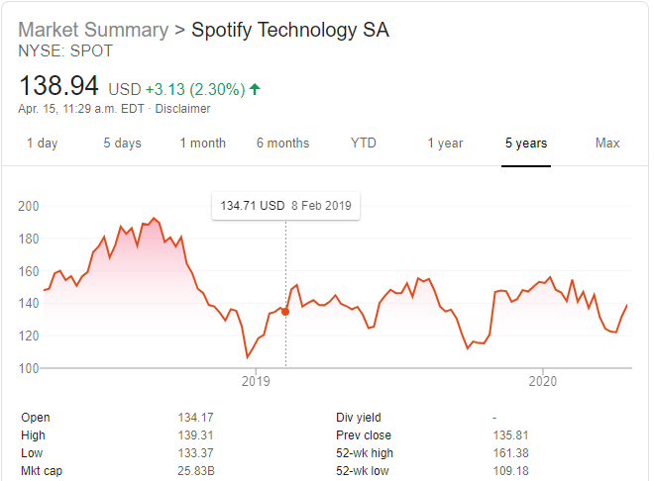

**Volunteer Presentations -** Please note that one or two teams will be asked to present their conclusions (presentation) at this same class session. Teams may volunteer for this request. In the absence of any volunteer teams, the instructor will assign the presentation requirement to two of the teams.